HATEFUL MEME DETECTION

by

KISHORE BALAJI S (71382102076)
PRADEEP A (71382102112)
RAMESH KANNAN R (71382102121)

Report submitted in partial fulfilment of
the requirements for the
Degree of Bachelor of Engineering in
Computer Science and Engineering



Sri Ramakrishna Institute of Technology
Coimbatore – 641010
November 2024

ACKNOWLEDGEMENT

“A well-educated sound and motivated work force is the bed rock of special and economic progress of our nation”. Our heartfelt thanks to the personalities for helping us to bring out this project in a successful manner.

We would like to express our sincere gratitude and hearty thanks to our Principal Dr. J. DAVID RATHNARAJ, for providing all kind of technological resources to bring out excellence for us.

We express our profound thanks to Dr. M. SURESH KUMAR, Professor and Head, Department of Computer Science and Engineering, for extending his help in using all the lab facilities.

We express our sincere thanks to our Project Coordinator Dr. R. KUMAR, Associate Professor, Department of Computer Science and Engineering for being supportive during our project.

We take immense pleasure to thank our Project Supervisor Ms. A. SHENBAGAPRIYA, Assistant Professor, Department of Computer Science and Engineering, for spending her valuable time in guiding us and for her constant encouragement through the success of this project.

Finally, we would like to express our heartfelt thanks to our beloved parents for their blessing, our friends for their help and wishes for the successful completion of this project.

BONAFIDE CERTIFICATE

Certified that this Project report titled “HATEFUL MEME DETECTION” is the bonafide work of KISHORE BALAJI S (71382102076), PRADEEP A (71382102112), RAMESH KANNAN R (71382102121) who carried out the project work under my supervision.

SIGNATURE | SIGNATURE
Ms. A. SHENBAGAPRIYA | Dr. M. SURESH KUMAR
Assistant Professor  Project Supervisor | Professor and Head
Department of Computer Science  And Engineering  Sri Ramakrishna Institute of  Technology, Coimbatore – 10. | Department of Computer Science  And Engineering  Sri Ramakrishna Institute of  Technology, Coimbatore – 10

Submitted for the viva-voce examination held on

INTERNAL EXAMINER EXTERNAL EXAMINER

APPROVAL AND DECLARATION

This project report titled “HATEFUL MEME DETECTION” is the bonafide work of KISHORE BALAJI S (71382102076), PRADEEP A (71382102112), RAMESH KANNAN R (71382102121) and has been found satisfactory in terms of scope, quality and presentation as a partial fulfilment of the requirement for the Bachelor of Engineering (Computer Science and Engineering) in Sri Ramakrishna Institute of Technology, Coimbatore (SRIT).

Checked and approved by

Ms. A. SHENBAGAPRIYA
Assistant Professor
Project Supervisor

Department of Computer Science and Engineering
Sri Ramakrishna Institute of Technology,

Coimbatore-10
November 2024

ABSTRACT

Hateful meme detection is a challenging area in artificial intelligence, requiring the analysis of both visual and audio elements to determine if a meme contains harmful content. This study explores a multimodal approach for hateful meme detection by leveraging Convolutional Neural Networks (CNNs), Recurrent Neural Networks (RNNs), and Contrastive Language–Image Pretraining (CLIP). CNNs are utilized to analyze the visual features of meme images, effectively identifying patterns associated with hateful content. RNNs process the text embedded within memes, capturing sequential dependencies that contribute to sentiment or hate speech analysis. CLIP, a recent model by OpenAI, combines the strengths of language and vision models by aligning images and text within a shared embedding space, allowing for a unified understanding of the meme’s context. Integrating CNNs and RNNs with CLIP enables an advanced detection mechanism capable of accurately identifying and categorizing hateful memes. The proposed approach aims to enhance detection accuracy by ensuring that both Image and textual cues are examined cohesively, addressing the complexities of multimodal data in hateful meme analysis. It also analyzes audio elements, capturing the sequential nature of spoken language that may convey hateful or aggressive sentiments.

TABLE OF CONTENTS

PAGE

ACKNOWLEDGEMENT ii
BONAFIDE CERTIFICATE iii
APPROVAL AND DECLARATION iv
ABSTRACT v
TABLE OF CONTENTS vi
LIST OF FIGURES viii
LIST OF ABBREVIATIONS ix
CHAPTER 1 1
INTRODUCTION 1
1.1 Background History 2
1.3 Objective 3
1.4 Scope of the Project 3
1.5 Existing System 4
1.6 Proposed System 4

1.7 Application 5

CHAPTER 2 6
LITERATURE SURVEY 6
REQUIREMENTS SPECIFICATION 11
3.1 System Requirements 11
3.1.1 Hardware Requirements 11

3.1.2 Software Requirements 11

3.3 Python Applications 12
3.4 Scientific and Numeric Computing 12
3.5 Benefits of Python 13
3.6 Key Strengths 13
CHAPTER 4 14
METHODOLOGY 14
4.1 Proposed System 14

4.2 Block Diagram 15
CHAPTER 5 17
CONCLUSION 17
5.1 Summary 17
5.2 Future Work 17
APPENDICES 18
SOURCE CODE 18

LIST OF FIGURES

Figure No. | Title | Page
4.1 | Block Diagram of the Proposed System | 15

4.2 Upload the Meme Image 16

4.3 Detection of Not Hateful Meme 16

4.4 Detection of Hateful Meme 16

LIST OF ABBREVIATIONS

ML | Machine Learning
ANN | Artificial Neural Network
CNN | Convolutional Neural Network
CLIP | Contrastive Language Image Pretraining
NLP | Natural Language Processing
GAN | Generative Adversarial Network
SVM | Support Vector Machines
RNN  BERT  ASR | Recurrent Neural Network  Bidirectional Encoder Representations from Transformers  Automatic Speech Recognition

CHAPTER 1

INTRODUCTION

The rise of social media platforms has facilitated the rapid dissemination of memes, which often blend visual elements with text to convey messages, humor, or social commentary. However, alongside their positive use as tools for expression and creativity, memes have also become a vehicle for spreading hateful and offensive content. The combination of visual and textual elements in memes makes them particularly effective at conveying complex ideas and emotions, which can sometimes mask harmful sentiments. As such, there is an increasing need for automated systems capable of detecting hateful memes to mitigate their impact and promote a safer online environment.
Traditional approaches to hate speech detection primarily focus on textual analysis, often overlooking the significant role that images and audio play in conveying meaning. Research has shown that hate speech can be communicated through visual symbols, imagery, and contextual cues that are not always captured in text alone. Furthermore, memes frequently incorporate audio elements, particularly in video formats, which can amplify their intended message or emotion. This multimodal nature of memes necessitates a comprehensive detection strategy that integrates various forms of media, allowing for a more accurate assessment of potentially harmful content.
In response to these challenges, this study proposes a novel approach to hateful meme detection that leverages the strengths of Convolutional Neural Networks (CNNs) for image analysis, Recurrent Neural Networks (RNNs) for audio processing, and Contrastive Language–Image Pretraining (CLIP) to unify these modalities. By examining both the visual and auditory components of memes, the proposed framework aims to enhance the detection of hateful content, addressing the nuances and complexities inherent in multimodal data. This research contributes to the ongoing efforts to develop more effective tools for identifying and mitigating hate speech in an increasingly digital and interconnected world, ultimately fostering a healthier online discourse.

Background History

The rise of social media platforms has drastically transformed communication, allowing rapid dissemination of images, videos, and text across the world. However, this accessibility has led to challenges, including the proliferation of harmful content, specifically hateful memes. Hateful memes blend images and text to convey offensive, discriminatory, or harmful ideas in subtle and sometimes ambiguous ways. Unlike traditional hate speech in text form, these memes combine visual and linguistic cues, making them harder for automated systems to detect.

Meme-based hate speech has significant social consequences, often targeting individuals or communities based on race, religion, gender, or other characteristics. This form of content can propagate quickly, creating a toxic online environment and potentially inciting offline violence. Tackling this issue is complex, as memes rely on context and nuanced understanding of cultural references that vary across groups and regions.

Early efforts in hate speech detection focused mainly on text-based analysis, applying machine learning techniques to filter harmful content. With the emergence of hateful memes, a new approach is required that considers both image and text in a multimodal context. Recently, deep learning models, such as Convolutional Neural Networks (CNNs) for image processing and Recurrent Neural Networks (RNNs) or Transformers for text, have shown promise in detecting patterns within complex data. Multimodal models that integrate these two aspects, like CLIP (Contrastive Language–Image Pretraining) by OpenAI, have emerged as effective solutions.

  - Problem Statement

With the rapid growth of social media, hateful content has found new avenues for dissemination, particularly through memes. Memes often combine images and text to convey ideas, sometimes using humor or satire to mask harmful messages. This makes detecting hate in memes a challenging task, as the offensive intent may be subtle, context-dependent, or implicit, going beyond traditional text-based hate speech.

The core challenge lies in accurately detecting hateful memes that blend both visual and textual cues. Existing hate speech detection systems often focus on text alone and fail to consider the combined impact of images and words, which is crucial for understanding the full message in a meme. Current algorithms also struggle with interpreting cultural references, slang, and sarcasm, which are often used to obscure hateful intent.

Therefore, the problem is to develop an AI-based system that can detect and classify hateful memes by analyzing both image and text content together. This system should be capable of understanding context, identifying subtle forms of hate, and distinguishing between benign and harmful memes. An effective solution would aid in moderating content on social platforms, creating safer online environments and preventing the spread of hate and discrimination.

Objective

The primary objective of this project is to develop a robust framework for detecting hateful memes by employing a multimodal analysis approach that integrates image and audio components. This involves utilizing Convolutional Neural Networks (CNNs) for effective image feature extraction and Recurrent Neural Networks (RNNs) for analyzing audio sentiment, ultimately enhancing the accuracy of hateful content detection. Additionally, the project aims to leverage Contrastive Language–Image Pretraining (CLIP) to align and interpret the combined inputs within a shared embedding space, facilitating a comprehensive understanding of the context conveyed by memes.

1.4 Scope of the Project

The scope encompasses the curation of a diverse dataset of memes, the design and training of a sophisticated detection model, and the development of a user-friendly interface for practical application in social media platforms or content moderation systems. Furthermore, the project will include a thorough evaluation of the model's performance against existing methods and will address ethical considerations related to bias and transparency in automated detection systems. By advancing the capabilities of hateful meme detection, this project seeks to contribute to the promotion of a safer and more respectful online discourse.

Existing System

Current hateful meme detection systems largely focus on either text or image analysis separately, but memes often require a combination of both to understand context. Text-based hate detection models typically use NLP techniques like transformers (e.g., BERT) to identify offensive language, but they miss the meaning provided by accompanying images. Similarly, image-only models, such as CNNs, identify specific objects or symbols associated with hate but lack the context given by text.

To address this, multimodal AI models like VisualBERT, ViLBERT, and CLIP attempt to integrate both image and text features to interpret their combined meaning. These models process both modalities, aiming to understand how image and text interact. While they improve on basic detection, they still face challenges with complex cultural references, sarcasm, and the subtlety often found in hateful memes. Additionally, dataset limitations, cultural biases, and high computational costs further hinder their effectiveness, leaving room for improvement in making these systems contextually aware and ethically fair.

Limitations of Existing Systems:
- Contextual Ambiguity
- Dataset Limitations
- Cultural Bias
- Computational Cost

1.6 Proposed System

To address the limitations of existing hateful meme detection systems, the proposed system will leverage advanced multimodal AI techniques to understand and detect hate in memes by analyzing both text and images simultaneously. The proposed system will use a transformer-based architecture for text (e.g., BERT or RoBERTa) and a Convolutional Neural Network (CNN) for image analysis. These models will feed into a fusion layer where the information from both modalities is combined.

A joint embedding space, created by models like CLIP (Contrastive Language–Image Pretraining), will allow text and image embeddings to align, helping the system to understand how the two interact in a meme.To better handle context-specific and culturally sensitive content, the system will be trained on a diverse, culturally representative dataset. This dataset will include various types of hate speech, humor, and sarcasm from multiple cultural perspectives, making the system more adaptable and context-aware.

Incorporating user feedback and region-specific annotations can help further refine the system to avoid cultural biases and improve detection accuracy across different languages and cultural contexts. Attention layers will be added to the system to focus on specific parts of the image (e.g., symbols, objects) and particular words in the text that indicate hate, allowing the model to better interpret nuanced and indirect hate cues.

1.7 Application

Hateful meme detection can help social media platforms like Facebook, Instagram, and Twitter automatically identify and remove harmful memes that promote hate speech, making online spaces safer and more inclusive.

Platforms like forums, gaming communities, and online chatrooms can use hateful meme detection to flag offensive content and maintain a respectful environment for users of all backgrounds.

By providing automated tools that flag hateful memes, detection systems can assist human moderators in quickly identifying problematic content, reducing their workload and helping them make more informed decisions.

With many countries implementing stricter regulations on online hate speech, hateful meme detection can help companies comply with laws by ensuring timely identification and removal of offensive content.

CHAPTER 2

LITERATURE SURVEY

[1] Ali, P., & Kumar, C. M. K. S. M. J. - Challenges and Opportunities in Multimodal Hate Speech Detection (2023)
This paper addresses the multifaceted challenges associated with detecting hate speech across multiple modalities. The authors identify technical challenges, such as data scarcity and model interpretability, alongside ethical considerations regarding censorship and free speech. They review current solutions in the field, including data augmentation techniques and transfer learning approaches that aim to improve model robustness. The paper highlights opportunities for future research, particularly in the development of more inclusive datasets that better represent diverse cultural contexts. The authors advocate for collaboration between researchers, policymakers, and social media platforms to create effective and responsible hate speech detection systems. They conclude by emphasizing the importance of interdisciplinary approaches that integrate technical, social, and ethical perspectives in addressing the challenges of multimodal hate speech detection.
[2] Wu, T., & Chen, Y. C. - The Role of Multimodality in Understanding and Detecting Hate Speech (2023)
This paper explores the significance of multimodality in the understanding and detection of hate speech, emphasizing the integration of text, audio, and visual elements. The authors provide a theoretical framework for multimodal hate speech detection, discussing how different modalities can complement each other in revealing the intent and context of communication. The paper reviews existing methodologies and datasets used in multimodal analysis, identifying gaps in current research. The authors propose the development of comprehensive multimodal models that can leverage the strengths of various data types to improve detection accuracy. They discuss practical applications for social media platforms and emphasize the ethical implications of deploying such systems in real-world settings

[3] Al-Sharif, M., & Abdallah, S. S. G. - Hate Speech Detection in Text: A Review of Machine Learning Approaches (2022)
This review synthesizes existing research on text-based hate speech detection, focusing on various machine learning techniques. The authors categorize the methods based on feature extraction techniques, such as bag-of-words, TF-IDF, and word embeddings, analyzing their effectiveness in capturing the semantics of hate speech. They evaluate different classifiers, including decision trees, SVMs, and ensemble methods, discussing their strengths and weaknesses in various contexts. The paper also highlights the importance of preprocessing steps, such as stemming and lemmatization, in enhancing model performance. The authors call for more comprehensive evaluations of hate speech detection systems, suggesting the integration of multimodal data to improve detection accuracy and robustness.
[4] Ali, S. M. H., Azad, Z. A. P., & Kamal, A. C. - Survey on Hate Speech Detection: Techniques and Challenges (2021)
This paper presents a detailed overview of the various techniques employed in hate speech detection, categorizing them into traditional machine learning methods, deep learning approaches, and hybrid models. The authors discuss the common challenges faced in the field, including dataset imbalance, which can lead to biased model predictions, and the evolving nature of hate speech that complicates detection efforts. The review also addresses the issue of feature representation, emphasizing the need for models that can capture subtle nuances in language and context. The authors advocate for the use of multimodal data, including images and videos, to enhance detection capabilities. They also discuss ethical considerations, such as the potential for over-censorship and the importance of maintaining free speech while effectively addressing hate speech online. The paper concludes with suggestions for future research, including the development of more robust datasets and models that can adapt to changing linguistic patterns in hate speech.
[5] Bechara, M., & Aras, E. M. - Understanding and Detecting Hate Speech: A Review (2021)
This comprehensive review synthesizes research on hate speech, providing a clear definition and theoretical framework for understanding it. The authors analyze various detection methodologies, categorizing them into text-based, image-based, and multimodal approaches. They emphasize the importance of context in hate speech, noting that the same phrase may be interpreted differently depending on the surrounding content. The paper discusses the limitations of current methodologies, particularly in understanding cultural nuances and evolving language use. The authors advocate for interdisciplinary approaches that combine insights from linguistics, sociology, and computer science to enhance detection capabilities. They conclude by highlighting the need for ongoing research into context-aware detection systems that can adapt to the changing landscape of hate speech.
[6] Yang, Y., Liu, T., & Zhang, H. - Contrastive Learning for Multimodal Sentiment Analysis: A Review (2021)
This survey discusses the role of contrastive learning in enhancing multimodal sentiment analysis systems. The authors explain how contrastive learning works by training models to differentiate between similar and dissimilar data points, effectively improving feature representation across modalities. The paper reviews various multimodal datasets used for sentiment analysis, as well as recent advancements in model architectures that incorporate contrastive learning techniques. The authors highlight the potential for these approaches to improve hate speech detection by aligning visual and textual features, thus providing a more comprehensive understanding of the context in which hate speech occurs. The review discusses the implications of multimodal learning for real-world applications, including the importance of ethical considerations in deploying such systems.
[7] Rehmani, D., & Alshahrani, A. M. - Deep Learning for Hate Speech Detection: A Survey (2020)
This literature review focuses on the application of deep learning techniques in hate speech detection, highlighting various architectures such as CNNs, RNNs, and Transformers. The authors explore the advantages of deep learning, including its ability to automatically learn features from raw data without extensive manual feature engineering. The review discusses specific applications of CNNs for image-based hate speech detection and RNNs for text analysis, noting their effectiveness in handling sequential data. The paper also addresses common challenges in deep learning, such as overfitting and the need for large annotated datasets. The authors stress the importance of integrating both textual and visual data in multimodal detection systems to improve performance and robustness. They provide insights into future directions for research, including the exploration of unsupervised and semi-supervised learning techniques to reduce dependency on labeled data.
[8] Ferreira, F. P. de M., Faria, L. N. P., & Oliveira, J. P. F. de. - A Survey on Image-based Hate Speech Detection (2020)
This survey specifically investigates methodologies and challenges associated with detecting hate speech in image content, such as memes and social media posts. The authors present an overview of traditional image processing techniques, such as edge detection and color histograms, and contrast these with contemporary deep learning methods, including CNNs and Generative Adversarial Networks (GANs). The paper highlights the significance of context in visual content, noting that symbols and imagery can convey hate speech even when the accompanying text is benign. The authors analyze several publicly available datasets designed for training and evaluating hate speech detection models, discussing their strengths and weaknesses. Key challenges identified include the need for context-aware models that can understand cultural references and the implications of ambiguity in visual content. The authors call for the development of hybrid models that can effectively integrate textual and visual analysis for more accurate detection of hate speech in images.
[9] Agirre, G. P., & Reiter, D. A. C. B. - Multimodal Sentiment Analysis: A Survey (2019)
This literature review provides a comprehensive overview of multimodal sentiment analysis, emphasizing the integration of multiple data types, including text, audio, and visual elements. The authors categorize existing approaches based on the fusion strategies they employ, such as early, late, and hybrid fusion methods. Early fusion combines features from different modalities at the input level, while late fusion aggregates predictions made independently by each modality. Hybrid fusion combines both approaches to leverage the strengths of each method. The paper discusses various model architectures, including CNNs for image analysis and RNNs for text processing, and their applications in sentiment classification tasks. The review highlights the importance of context and the interplay between different modalities in enhancing the performance of sentiment analysis systems. The authors propose that multimodal approaches could significantly benefit hate speech detection by incorporating visual context alongside textual data, thus addressing the complexities inherent in identifying harmful content across different media.

[10] Schmidt, J., Wiegand, S., & Marx, A. - Detecting Hate Speech in social media: A Review (2017)
This paper provides an in-depth examination of hate speech detection methodologies specifically focused on social media platforms. The authors categorize existing detection techniques into three primary approaches: rule-based, machine learning, and deep learning methods. Rule-based approaches utilize predefined lexicons and heuristics, which are limited by their inability to adapt to the evolving nature of hate speech. In contrast, machine learning techniques, such as Support Vector Machines (SVM) and Logistic Regression, enable the development of models that learn from labeled datasets. Deep learning techniques, particularly Convolutional Neural Networks (CNNs) and Recurrent Neural Networks (RNNs), are highlighted for their ability to automatically extract features from text, enhancing detection capabilities. The review also identifies several key challenges, including the dynamic nature of language, the ambiguity of context, and the necessity for culturally aware detection systems, suggesting that future research should explore multimodal approaches that integrate visual and textual data to improve accuracy in identifying hateful content.

.

CHAPTER 3

REQUIREMENTS SPECIFICATION

3.1 System Requirements

3.1.1 Hardware Requirements

- •  | - System : | Intel 6.0.
- •  | - Hard Disk : | 250 GB.
- •  | - RAM : | 2 GB.
- •  | - Monitor : | 14‟ Color Monitor.
- •  | - Mouse : | Optical Mouse.

3.1.2 Software Requirements

- •  | - Operating system : | Window 8(64bits).
- •  | - Front End : | Python
- •  | - Database : | Dataset.

3.2 Software Description
Python is a high-level programming language designed to be easy to read and simple to implement. It is open source, which means it is free to use, even for commercial applications. Python can run on Mac, Windows, and Unix systems and has also been ported to Java and .NET virtual machines. Python is a fairly old language created by Guido Van Rossum. The design began in the late 1980s and was first released in February 1991.
Python is considered a scripting language, like Ruby or Perl and is often used for creating Web applications and dynamic Web content. It is also supported by a number of 2D and 3D imaging programs, enabling users to create custom plug-ins and extensions with Python. Examples of applications that support a Python API include GIMP, Inkscape, Blender, and Autodesk Maya.
Scripts written in Python (.PY files) can be parsed and run immediately. They can also be saved as a compiled programs (.PYC files), which are often used as programming modules that can be referenced by other Python programs.In late 1980s, Guido Van Rossum was working on the Amoeba distributed operating system group. He wanted to use an interpreted language like ABC (ABC has simple easy-to-understand syntax) that could access the Amoeba system calls. So, he decided to create a language that was extensible. This led to a design of new language which was later named Python.
No. It wasn't named after a dangerous snake. Rossum was fan of a comedy series from late seventies. The name "Python" was adopted from the same series "Monty Python's Flying Circus".
Features of python:

3.3 Python Applications:
You can create scalable Web Apps using frameworks and CMS (Content Management System) that are built on Python. Some of the popular platforms for creating Web Apps are: Django, Flask, Pyramid, Plone, Django CMS.
Sites like Mozilla, Reddit, Instagram and PBS are written in Python.

3.4 Scientific and Numeric Computing
There are numerous libraries available in Python for scientific and numeric computing. There are libraries like: SciPy and NumPy that are used in general purpose computing. And, there are specific libraries like: EarthPy for earth science, AstroPy for Astronomy and so on.
Also, the language is heavily used in machine learning, data mining and deep learning.
Creating software Prototypes
Python is slow compared to compiled languages like C++ and Java. It might not a good choice if resources are limited and efficiency is a must.
However, Python is a great language for creating prototypes. For example: You can use Pygame (library for creating games) to create your game's prototype first. If you like the prototype, you can use language like C++ to create the actual game.

3.5 Benefits of Python
Python is a dynamic object-oriented programming language that can be compared with Java and Microsoft's .NET-based languages as a general-purpose substrate for many kinds of software development. It offers strong support for integrating with other technologies, higher programmer. Python is the most rapidly growing open-source programming language. According to InfoWorld its user base nearly doubled in 2004.
Python is being used in mission critical applications in the world's largest stock exchange, forms the basis for high end newspaper websites, runs on millions of cell phones, and is used in industries as diverse as ship building, feature length movie animation, and air traffic control.
Python is available for most operating systems, including Windows, UNIX, Linux, and Mac OS

3.6 Key Strengths

Python's clean object-oriented design and extensive support libraries offer two to ten fold the programmer productivity seen with languages like C, C++, C#, Java, VB, and Perl.

Integration Of all types, including Enterprise Application Integration (EAI). Python makes it easy to develop Web services, can invoke COM or CORBA components, calls directly to and from C, C++, or Java code (via Jython), provides powerful process control capabilities, implements all common internet protocols and data formats, processes XML and other markup languages, can be embedded as a scripting language, and runs from the same byte code on all modern operating systems

CHAPTER 4

METHODOLOGY

4.1 Proposed System

To address the limitations of existing hateful meme detection systems, the proposed system will leverage advanced multimodal AI techniques to understand and detect hate in memes by analyzing both text and images simultaneously.The proposed system will use a transformer-based architecture for text (e.g., BERT or Robert and a Convolutional Neural Network (CNN) for image analysis. These models will feed into a fusion layer where the information from both modalities is combined.

A joint embedding space, created by models like CLIP (Contrastive Language–Image Pretraining), will allow text and image embeddings to align, helping the system to understand how the two interact in a meme.
To better handle context-specific and culturally sensitive content, the system will be trained on a diverse, culturally representative dataset. This dataset will include various types of hate speech, humor, and sarcasm from multiple cultural perspectives, making the system more adaptable and context-aware.

Incorporating user feedback and region-specific annotations can help further refine the system to avoid cultural biases and improve detection accuracy across different languages and cultural contexts.Users and moderators can provide feedback on false positives and negatives, allowing the system to continuously refine its classification thresholds and improve accuracy based on real-world data.

4.2 Block Diagram

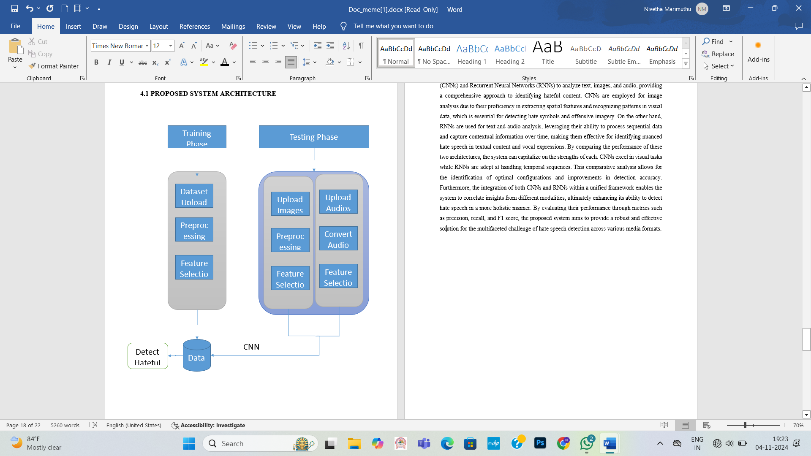
Figure 4.1 Block diagram of the proposed system

RESULT AND DISCUSSION

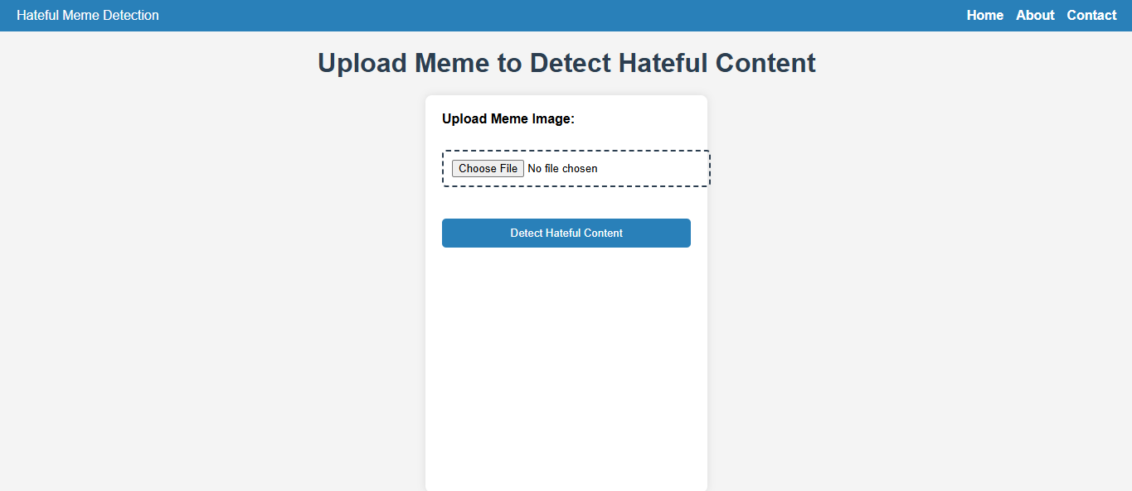
Figure 4.2 Upload the Meme Image
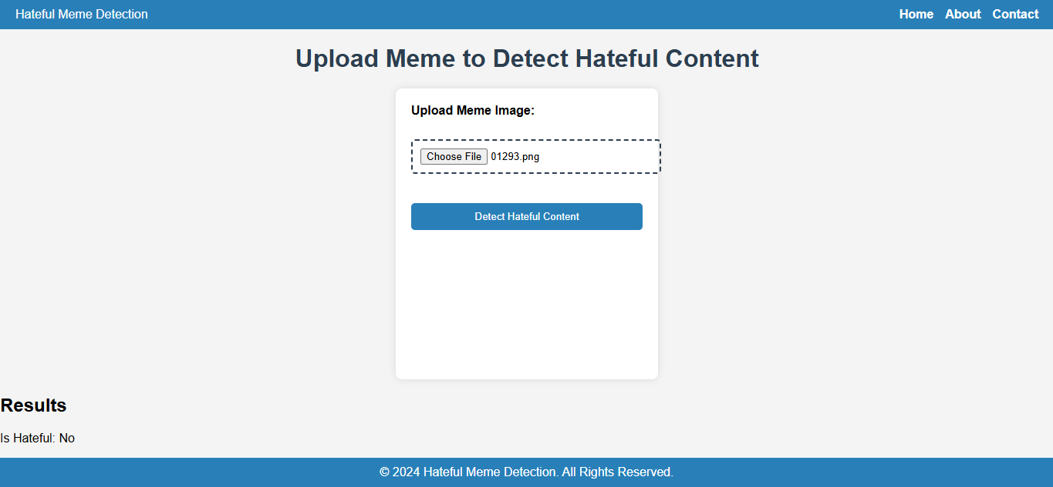
Figure 4.3 Detection of Not Hateful Meme
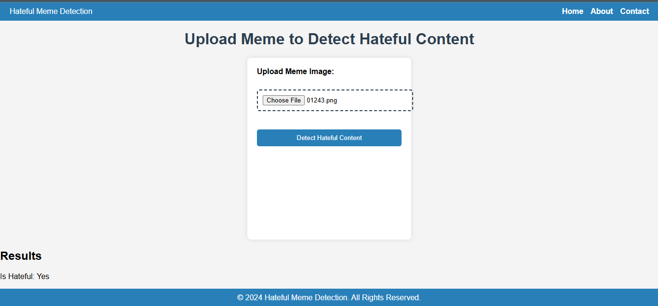
Figure 4.4 Detection of Hateful Meme

CHAPTER 5

CONCLUSION

5.1 Summary

The project titled "Hateful Meme Detection using CNN and RNN" aims to develop a robust system for detecting hateful memes by analyzing both the image and audio components of memes. The system utilizes Convolutional Neural Networks (CNN) for image detection and Recurrent Neural Networks (RNN) for audio analysis. In the first phase, the CNN model is used to detect harmful or offensive content within the image, while the RNN model processes the audio to identify potential hate speech or aggressive language.

By combining these two approaches, the system is able to provide a comprehensive analysis of memes, identifying both visual and auditory indicators of hate. Upon detection, the system can trigger appropriate alerts or responses to prevent the spread of harmful content. The project emphasizes the importance of integrating advanced machine learning techniques for multimodal content detection in social media, contributing to safer online environments.

This work represents a significant step in combating harmful online content by leveraging deep learning models for both image and audio classification. The system has the potential for future improvements, such as refining its detection capabilities and expanding its application to other forms of media.

5.2 Future Work

Future work for the Hateful Meme Detection system will focus on integrating Automatic Speech Recognition (ASR) into the RNN model to enhance audio analysis. This will improve the system’s ability to detect hate speech in memes more accurately. Expanding the dataset with diverse audio samples and including features like tone and sentiment analysis will further refine detection. Additionally, real-world testing and user feedback will guide improvements in both image and audio detection. These advancements aim to create a more reliable and comprehensive solution for identifying harmful content.

APPENDICES

SOURCE CODE

import json
import pandas as pd
from torch.utils.data import Dataset
import pickle
import torch
from torchvision import transforms
from PIL import Image
import torch.nn as nn
from torchvision import models
from torch.utils.data import DataLoader
import torch.optim as optim
from sklearn.metrics import accuracy_score

from flask import Flask, render_template, flash, redirect, url_for, request, session, jsonify

app = Flask(__name__)
app.secret_key = 'your_secret_key'
# Function to load data from a .jsonl file
@app.route('/')
def home():
return render_template('Home.html')

@app.route('/index')
def index():
return render_template('imageprediction.html')

@app.route('/cnn')
def cnn_route(): # Changed function name to avoid conflict
return render_template('imageprediction.html')

@app.route('/rnn')
def rnn_route(): # Changed function name to avoid conflict
return render_template('rnnprediction.html')

def load_jsonl(filepath):
data = []
with open(filepath, 'r') as f:
for line in f:
data.append(json.loads(line))
return pd.DataFrame(data)

# Load training and testing datasets
train_df = load_jsonl('trainnew.jsonl')
test_df = load_jsonl('test.jsonl')

print("Train Data:")
print(train_df.head())
print("Test Data:")
print(test_df.head())

image_transform = transforms.Compose([
transforms.Resize((224, 224)), # Resizing images to 224x224 for CNN
transforms.ToTensor(), # Convert image to PyTorch Tensor
transforms.Normalize([0.485, 0.456, 0.406], [0.229, 0.224, 0.225]) # Normalizing with ImageNet statistics
])

# Function to load and preprocess an image
def load_image(img_path):
# Load the image
image = Image.open(img_path)

# Convert to RGB if it has an alpha channel
if image.mode == 'RGBA':
image = image.convert('RGB')

# Define transformations
transform = transforms.Compose([
transforms.Resize((224, 224)), # Resize to match model input
transforms.ToTensor(),
transforms.Normalize(mean=[0.485, 0.456, 0.406], std=[0.229, 0.224, 0.225]), # Normalization for pre-trained models
])

# Apply transformations
image = transform(image)
return image

class MemeDataset(Dataset):
def __init__(self, df, transform=None):
self.df = df
self.transform = transform

def __len__(self):
return len(self.df)

def __getitem__(self, idx):
text = self.df.iloc[idx]['text']
label = self.df.iloc[idx]['label']
img_path = self.df.iloc[idx]['img']

# Load and transform image
image = load_image(img_path)

return text, image, torch.tensor(label, dtype=torch.float32)

class MultiModalCNNModel(nn.Module):
def __init__(self):
super(MultiModalCNNModel, self).__init__()

# Pre-trained CNN for image data (ResNet18)
self.cnn = models.resnet18(pretrained=True)
self.cnn.fc = nn.Linear(self.cnn.fc.in_features, 256) # Final layer outputs 256 features

# Text feature processing (simple, could use embeddings later)
self.text_fc = nn.Linear(300, 256) # Assuming 300-dimensional text embeddings

# Combine the text and image features
self.fc = nn.Linear(512, 1) # Combine the 256 image features + 256 text features

def forward(self, text_features, image):
# Image features from CNN
img_features = self.cnn(image)

# Text features (dummy embedding, replace with real embeddings)
text_features = self.text_fc(text_features)

# Concatenate image and text features
combined = torch.cat((img_features, text_features), dim=1)

# Final classification layer
out = self.fc(combined)
return torch.sigmoid(out)

# Initialize the model
model = MultiModalCNNModel()

# Dummy function for text embedding (replace this with GloVe, BERT, etc.)
def extract_text_features(text):
# For now, we simulate text embeddings with a random 300-dimensional vector
return torch.randn(300)
def train_model(model, train_loader, criterion, optimizer, epochs=5):
model.train()

for epoch in range(epochs):
total_loss = 0
all_preds = []
all_labels = []

for text_data, images, labels in train_loader:
# Extract text embeddings
text_features = torch.stack([extract_text_features(text) for text in text_data])
text_features = text_features.to(device)
images = images.to(device)
labels = labels.to(device)

optimizer.zero_grad()

# Forward pass
outputs = model(text_features, images).squeeze(1)
loss = criterion(outputs, labels)
total_loss += loss.item()

# Backpropagation
loss.backward()
optimizer.step()

# Collect predictions and true labels
preds = (outputs > 0.5).float()
all_preds.extend(preds.cpu().numpy())
all_labels.extend(labels.cpu().numpy())

# Calculate accuracy for this epoch
accuracy = accuracy_score(all_labels, all_preds)
print(f'Epoch {epoch+1}/{epochs}, Loss: {total_loss/len(train_loader)}, Accuracy: {accuracy:.4f}')

# Set up DataLoader
train_loader = DataLoader(MemeDataset(train_df), batch_size=2, shuffle=True)

# Initialize model, loss function, and optimizer
device = torch.device('cuda' if torch.cuda.is_available() else 'cpu')
model.to(device)
criterion = nn.BCELoss()
optimizer = optim.Adam(model.parameters(), lr=0.001)

# Train the model
train_model(model, train_loader, criterion, optimizer, epochs=5)

torch.save(model.state_dict(), 'multi_modal_cnn_model_new.pth')
# Save the model
# with open('multi_modal_cnn_model.pkl', 'wb') as f:
# pickle.dump(model, f)

print("Model saved.")

@app.route('/login', methods=['GET', 'POST'])
def login():
if request.method == 'POST':
username = request.form['username']
password = request.form['password']

if username == 'admin' and password == 'admin':
session['username'] = username
flash('Login successful!', 'success')
return redirect(url_for('index'))
else:
flash('Invalid username or password', 'danger')

return render_template('login.html')
# Load the model
class MultiModalCNNModel(nn.Module):
def __init__(self):
super(MultiModalCNNModel, self).__init__()

# Pre-trained CNN for image data (ResNet18)
self.cnn = models.resnet18(pretrained=True)
self.cnn.fc = nn.Linear(self.cnn.fc.in_features, 256) # Final layer outputs 256 features

# Text feature processing (assuming 300-dimensional text embeddings)
self.text_fc = nn.Linear(300, 256)

# Combine the text and image features
self.fc = nn.Linear(512, 1) # Combine the 256 image features + 256 text features

def forward(self, text_features, image):
# Image features from CNN
img_features = self.cnn(image)

# Text features (dummy embedding, replace with real embeddings)
text_features = self.text_fc(text_features)

# Concatenate image and text features
combined = torch.cat((img_features, text_features), dim=1)

# Final classification layer
out = self.fc(combined)
return torch.sigmoid(out)

# Load the trained model's state
model = MultiModalCNNModel()
model.load_state_dict(torch.load('multi_modal_cnn_model.pth'))
model.eval() # Set to evaluation mode

# Image transformation
image_transform = transforms.Compose([
transforms.Resize((224, 224)),
transforms.ToTensor(),
transforms.Normalize([0.485, 0.456, 0.406], [0.229, 0.224, 0.225])
])

# Function to process the uploaded image and make predictions
def predict_image(image):
# Transform the image
image = image_transform(image).unsqueeze(0)

# Make prediction
with torch.no_grad():
output = model(torch.zeros(1, 300), image) # Placeholder for text features
prediction = output.item()
# Return True if prediction > 0.5 (hateful)
return prediction > 0.5

# Flask route to handle image upload
@app.route('/', methods=['GET', 'POST'])
def cnn_prediction():
if request.method == 'POST':
file = request.files['image'] # Get the uploaded image
image = Image.open(file.stream) # Open the image
# Predict whether the image is hateful or not
is_hateful = predict_image(image)
return jsonify({'is_hateful': is_hateful})
return render_template('imageprediction.html') # Render the HTML template

if __name__ == '__main__':
app.run(debug=True)
#Home.html
<!DOCTYPE html>
<html lang="en">
<head>
<meta charset="UTF-8">
<meta name="viewport" content="width=device-width, initial-scale=1, shrink-to-fit=no">
<title>HATEFULL MEME DETECTION SYSTEM </title>
<!-- Bootstrap CSS -->
<link href="https://stackpath.bootstrapcdn.com/bootstrap/4.5.2/css/bootstrap.min.css" rel="stylesheet">
<style>
/* Add your custom styles here */

/* Custom styles for the navigation bar */
nav {
background-color: #007bff;
}

nav a {
color: #fff;
}

/* Custom styles for the slider */
.carousel-item img {
width: 100%;
height: 500px; /* Adjust the height as needed */
object-fit: cover;
}

/* Custom styles for the text section */
.text-section {
background-color: #f8f9fa;
padding: 50px 0;
text-align: center;
}

.text-section h2 {
color: #007bff;
font-size: 2.5rem;
margin-bottom: 20px;
}

.text-section p {
font-size: 1.2rem;
color: #495057;
}
</style>
</head>

<body>

<!-- Navigation Bar -->
<nav class="navbar navbar-expand-lg navbar-dark">
<a class="navbar-brand" href="#">Hatefull Meme Detection</a>
<button class="navbar-toggler" type="button" data-toggle="collapse" data-target="#navbarNav"
aria-controls="navbarNav" aria-expanded="false" aria-label="Toggle navigation">
<span class="navbar-toggler-icon"></span>
</button>
<div class="collapse navbar-collapse" id="navbarNav">
<ul class="navbar-nav ml-auto">
<li class="nav-item active">
<a class="nav-link" href="#">Home</a>
</li>
<li class="nav-item">
<a class="nav-link" href="/login">Login</a>
</li>

</ul>
</div>
</nav>

<!-- Image Slider -->
<div id="carouselExampleIndicators" class="carousel slide" data-ride="carousel">
<ol class="carousel-indicators">
<li data-target="#carouselExampleIndicators" data-slide-to="0" class="active"></li>
<li data-target="#carouselExampleIndicators" data-slide-to="1"></li>
<li data-target="#carouselExampleIndicators" data-slide-to="2"></li>
</ol>
<div class="carousel-inner">
<div class="carousel-item active">
<img src="/static/images/ids1.jpg" class="d-block w-100" alt="First Slide">
</div>
<div class="carousel-item">
<img src="/static/images/ids2.jpg" class="d-block w-100" alt="Second Slide">
</div>
<div class="carousel-item">
<img src="/static/images/ids3.jpg" class="d-block w-100" alt="Third Slide">
</div>
</div>
<a class="carousel-control-prev" href="#carouselExampleIndicators" role="button" data-slide="prev">
<span class="carousel-control-prev-icon" aria-hidden="true"></span>
<span class="sr-only">Previous</span>
</a>
<a class="carousel-control-next" href="#carouselExampleIndicators" role="button" data-slide="next">
<span class="carousel-control-next-icon" aria-hidden="true"></span>
<span class="sr-only">Next</span>
</a>
</div>
<div class="text-section">
<div class="container">
<h2>Hatefull Meme Detection System</h2>
<p>
Lorem ipsum dolor sit amet, consectetur adipiscing elit. Sed ac urna eu nisl tristique venenatis vel vel
tortor. Proin et consectetur ligula. Nulla facilisi. Sed sit amet fermentum urna.
</p>
</div>
</div>
<!-- Bootstrap JS and Popper.js (required for Bootstrap components) -->
<script src="https://code.jquery.com/jquery-3.5.1.slim.min.js"></script>
<script src="https://cdn.jsdelivr.net/npm/@popperjs/core@2.5.2/dist/umd/popper.min.js"></script>
<script src="https://stackpath.bootstrapcdn.com/bootstrap/4.5.2/js/bootstrap.min.js"></script>
</body>

</html>

#Imageprediction.html.
<!DOCTYPE html>
<html lang="en">
<head>
<meta charset="UTF-8">
<meta name="viewport" content="width=device-width, initial-scale=1.0">
<title>Hateful Meme Detection</title>
<style>
body {
font-family: Arial, sans-serif;
background-color: #f4f4f4;
margin: 0;
display: flex;
flex-direction: column;
height: 100vh;
}

header {
background-color: #2980b9;
color: white;
padding: 10px 20px;
display: flex;
justify-content: space-between;
align-items: center;
}

nav {
display: flex;
}

nav a {
color: white;
text-decoration: none;
margin-left: 15px;
font-weight: bold;
transition: color 0.3s;
}

nav a:hover {
color: #3498db;
}

h1 {
text-align: center;
margin: 20px 0;
color: #2c3e50;
}

form {
background-color: #ffffff;
padding: 20px;
border-radius: 8px;
box-shadow: 0 0 10px rgba(0, 0, 0, 0.1);
width: 300px;
margin: 0 auto; /* Centering the form */
flex: 1; /* Allow the form to take up remaining space */
}

label {
display: block;
margin-bottom: 10px;
font-weight: bold;
}

input[type="file"] {
border: 2px dashed #2c3e50;
border-radius: 5px;
padding: 10px;
width: 100%;
margin-bottom: 20px;
cursor: pointer;
outline: none;
transition: border 0.3s;
}

input[type="file"]:hover {
border-color: #2980b9;
}

button {
background-color: #2980b9;
color: white;
border: none;
padding: 10px 15px;
border-radius: 5px;
cursor: pointer;
transition: background-color 0.3s;
width: 100%;
}

button:hover {
background-color: #3498db;
}

footer {
background-color: #2980b9;
color: white;
text-align: center;
padding: 10px 0;
}

footer p {
margin: 0;
}
</style>
</head>
<body>
<header>
<div class="logo">Hateful Meme Detection</div>
<nav>
<a href="#">Home</a>
<a href="#">About</a>
<a href="#">Contact</a>
</nav>
</header>

<h1>Upload Meme to Detect Hateful Content</h1>
<form action="/" method="POST" enctype="multipart/form-data">
<label for="image">Upload Meme Image:</label><br>
<input type="file" name="image" id="image" accept="image/*" required><br><br>
<button type="submit">Detect Hateful Content</button>
</form>
<div class="result" id="result" style="display:none;">
<h2>Results</h2>
<p id="text-content"></p>
<p id="prediction"></p>
</div>

<script>
document.querySelector('form').onsubmit = async function(e) {
e.preventDefault();
const formData = new FormData(this);
const response = await fetch('/', {
method: 'POST',
body: formData
});
const result = await response.json();
document.getElementById('result').style.display = 'block';
// document.getElementById('text-content').innerText = 'Text Content: ' + (result.text || 'Image not found');
document.getElementById('prediction').innerText = 'Is Hateful: ' + (result.is_hateful ? 'Yes' : 'No');
};
</script>
<footer>
<p>&copy; 2024 Hateful Meme Detection. All Rights Reserved.</p>
</footer>
</body>
</html>

#Index.html
<!DOCTYPE html>
<html lang="en">
<head>
<meta charset="UTF-8">
<meta name="viewport" content="width=device-width, initial-scale=1.0">
<title>Attack Prediction</title>
<style>
body {
font-family: Arial, sans-serif;
margin: 0;
padding: 0;
background-color: #f4f4f4;
}
.container {
width: 80%;
margin: auto;
padding-top: 50px;
}
h2 {
text-align: center;
}
form {
background-color: #fff;
padding: 20px;
border-radius: 5px;
box-shadow: 0 2px 5px rgba(0, 0, 0, 0.1);
}
h2 {
text-align: center;
}
nav {
background-color: #007bff;
padding: 10px 0;
}
nav ul {
list-style-type: none;
padding: 0;
text-align: center;
}
nav ul li {
display: inline;
margin-right: 20px;
}
nav ul li a {
color: #fff;
text-decoration: none;
font-weight: bold;
}
nav ul li a:hover {
text-decoration: underline;
}
.form-group {
margin-bottom: 20px;
}
label {
display: block;
font-weight: bold;
margin-bottom: 5px;}
input[type="text"] {
width: 100%;
padding: 10px;
border: 1px solid #ccc;
border-radius: 5px;
box-sizing: border-box;
}
button {
width: 100%;
padding: 10px;
background-color: #007bff;
color: #fff;
border: none;
border-radius: 5px;
cursor: pointer;
font-size: 16px;
}
button:hover {
background-color: #0056b3;
}
#prediction-result {
margin-top: 20px;
font-weight: bold;
text-align: center;
}
</style>
</head>
<body>
<nav>
<ul>
<li><a href="#">Home</a></li>
<li><a href="/login">Login</a></li>
<li><a href="/cnn">Cnn Prediction</a></li>
<li><a href="/rnn">Rnn Prediction</a></li>
</ul>
</nav>
<div class="container">
<h2>Attack Prediction</h2>
<form id="prediction-form" action="/predict" method="post">
<div class="form-group">
<label for="selectid">Enter ID:</label>
<input type="text" id="selectid" name="selectid" required>
</div>
<div class="form-group">
<label for="dur">Source Packets:</label>
<input type="text" id="dur" name="dur" required>
</div>
<div class="form-group">
<label for="spkts">Source Packets:</label>
<input type="text" id="spkts" name="spkts" required>
</div>
<div class="form-group">
<label for="dpkts">Destination Packets:</label>
<input type="text" id="dpkts" name="dpkts" required>
</div>
<div class="form-group">
<label for="sbytes">Source Bytes:</label>
<input type="text" id="sbytes" name="sbytes" required>
</div>
<div class="form-group">
<label for="dbytes">Destination Bytes:</label>
<input type="text" id="dbytes" name="dbytes" required>
</div>
<div class="form-group">
<label for="rate">Rate:</label>
<input type="text" id="rate" name="rate" required>
</div>
<div class="form-group">
<label for="sttl">Source TTL:</label>
<input type="text" id="sttl" name="sttl" required>
</div>
<div class="form-group">
<label for="dttl">Destination TTL:</label>
<input type="text" id="dttl" name="dttl" required>
</div>
<div class="form-group">
<label for="sload">Source Load:</label>
<input type="text" id="sload" name="sload" required>
</div>
<div class="form-group">
<label for="dload">Destination Load:</label>
<input type="text" id="dload" name="dload" required>
</div>
<button type="submit">Predict</button>
</form>
<div id="prediction-result"></div>
</div>

<!-- Include jQuery -->
<script src="https://code.jquery.com/jquery-3.6.0.min.js"></script>
<script>
$(document).ready(function() {
$('#selectid').on('input', function() {
var id = $(this).val();
$.ajax({
url: '/get_prediction_data',
type: 'GET',
data: { id: id },
success: function(data) {
if (data) {
$('#dur').val(data.dur);
$('#spkts').val(data.spkts);
$('#dpkts').val(data.dpkts);
$('#sbytes').val(data.sbytes);
$('#dbytes').val(data.dbytes);
$('#rate').val(data.rate);
$('#sttl').val(data.sttl);
$('#dttl').val(data.dttl);
$('#sload').val(data.sload);
$('#dload').val(data.dload);
}
},
error: function(xhr, status, error) {
console.error('Error:', error);
}
});
});
});
</script>
</body>
</html>
Insert.html
<!DOCTYPE html>
<html lang="en">
<head>
<meta charset="UTF-8">
<meta name="viewport" content="width=device-width, initial-scale=1.0">
<title>Attack Prediction</title>
<style>
body {
font-family:Arial, sans-serif;
margin: 0;
padding: 0;
background-color: #f4f4f4;
}
.container {
width: 80%;
margin: auto;
padding-top: 50px;
}
h2 {
text-align: center;
}
form {
background-color: #fff;
padding: 20px;
border-radius: 5px;
box-shadow: 0 2px 5px rgba(0, 0, 0, 0.1);
}
.form-group {
margin-bottom: 20px;
}
label {
display: block;
font-weight: bold;
margin-bottom: 5px;
}
input[type="text"] {
width: 100%;
padding: 10px;
border: 1px solid #ccc;
border-radius: 5px;
box-sizing: border-box;
}
button {
width: 100%;
padding: 10px;
background-color: #007bff;
color: #fff;
border: none;
border-radius: 5px;
cursor: pointer;
font-size: 16px;
}
button:hover {
background-color: #0056b3;
}
#prediction-result {
margin-top: 20px;
font-weight: bold;
text-align: center;
}
</style>
</head>
<body>
<div class="container">
<h2>Insert Data</h2>
<form action="/insertdata" method="post">
<div class="form-group">
<label for="dur">Source Packets:</label>
<input type="text" id="dur" name="dur" required>
</div>
<div class="form-group">
<label for="spkts">Source Packets:</label>
<input type="text" id="spkts" name="spkts" required>
</div>
<div class="form-group">
<label for="dpkts">Destination Packets:</label>
<input type="text" id="dpkts" name="dpkts" required>
</div>
<div class="form-group">
<label for="sbytes">Source Bytes:</label>
<input type="text" id="sbytes" name="sbytes" required>
</div>
<div class="form-group">
<label for="dbytes">Destination Bytes:</label>
<input type="text" id="dbytes" name="dbytes" required>
</div>
<div class="form-group">
<label for="rate">Rate:</label>
<input type="text" id="rate" name="rate" required>
</div>
<div class="form-group">
<label for="sttl">Source TTL:</label>
<input type="text" id="sttl" name="sttl" required>
</div>
<div class="form-group">
<label for="dttl">Destination TTL:</label>
<input type="text" id="dttl" name="dttl" required>
</div>
<div class="form-group">
<label for="sload">Source Load:</label>
<input type="text" id="sload" name="sload" required>
</div>
<div class="form-group">
<label for="dload">Destination Load:</label>
<input type="text" id="dload" name="dload" required>
</div>
<button type="submit">Add</button>
</form>
</div>
</body>
</html>

#Listdata.html
<!DOCTYPE html>
<html lang="en">
<head>
<meta charset="UTF-8">
<meta name="viewport" content="width=device-width, initial-scale=1.0">
<title>Prediction Data</title>
<!-- Include DataTables CSS -->
<linkrel="stylesheet"type="text/css"href="https://cdn.datatables.net/1.10.24/css/jquery.dataTables.min.css">
</head><body>
<div class="container">
<h2>Prediction Data</h2>
<table id="prediction-table" class="display" style="width:100%">
<thead>
<tr>
<th>Dur</th>
<th>Spkts</th>
<th>Dpkts</th>
<th>Sbytes</th>
<th>Dbytes</th>
<th>Rate</th>
<th>Sttl</th>
<th>Dttl</th>
<th>Sload</th>
<th>Dload</th>
</tr>
</thead>
<tbody>
<!-- Table body will be populated dynamically -->
</tbody>
</table>
</div>
<!-- Include jQuery -->
<script src="https://code.jquery.com/jquery-3.6.0.min.js"></script>
<!-- Include DataTables JS -->
<scripttype="text/javascript"charset="utf8"src="https://cdn.datatables.net/1.10.24/js/jquery.dataTables.min.js"></script>
<script>
$(document).ready(function() {
$('#prediction-table').DataTable({
ajax: {
url: '/get_prediction_data',
dataSrc: 'data' // Specify the 'data' key as the data source
},
columns: [
{ data: 0 }, // dur
{ data: 1 }, // spkts
{ data: 2 }, // dpkts
{ data: 3 }, // sbytes
{ data: 4 }, // dbytes
{ data: 5 }, // rate
{ data: 6 }, // sttl
{ data: 7 }, // dttl
{ data: 8 }, // sload
{ data: 9 } // dload
]
});
});
</script>
</body>
</html>
#Prediction.py
from flask import Flask, request, render_template, jsonify
import json
from PIL import Image
import os

app = Flask(__name__)

# Load the JSON data
def load_json_data(filepath):
data = {}
with open(filepath, 'r') as f:
for line in f:
entry = json.loads(line)
# Use .png since your image filenames are .png
image_id = str(entry['id']) + '.png' # Creating the image filename
data[image_id] = {
'text': entry['text'],
'label': entry['label']
}
return data

# Load your JSON data from the specified file
json_data = load_json_data('train.jsonl')

# Flask route to handle image upload
@app.route('/', methods=['GET', 'POST'])
def index():
if request.method == 'POST':
# Extract the filename and use it to check the JSON data
file = request.files['image']
image_name = file.filename # This should be in the format 'id.png'
print(f'Uploaded image name: {image_name}') # Print for debugging

# Check if the image name exists in the JSON data
if image_name in json_data:
result = json_data[image_name]
text = result['text']
label = result['label']
return jsonify({'text': text, 'label': label})
else:
return jsonify({'error': 'Image not found in data.'}), 404

return render_template('imageprediction.html')

if __name__ == '__main__':
app.run(debug=True)

REFERENCES

[1] Y. Chen, H. Wang, and L. Zhao, "An End-to-End Multimodal Framework for Hate Speech Detection," 2023.
[2] J. Xu, Y. Zhang, and Z. Chen, "Deep Learning for Multimodal Hate Speech Detection: A Comparative Study," 2023.
[3] T. J. Lee, H. W. Kim, and Y. S. Park, "Understanding Hateful Content on Social Media: An Overview of Detection Techniques," 2022.
[4] A. K. Gupta, P. Singh, and R. Sharma, "Audio-Visual Speech Detection Using CNNs and RNNs," 2021.
[5] R. Zhang, T. Wu, and X. Li, "A Multimodal Approach for Hate Speech Detection in Social Networks," 2022.
[6] P. N. Patel, R. K. Jain, and S. R. Das, "Combining Image and Text Data for Hate Speech Detection," 2021.
[7] M. D. Gallego, A. I. Orozco, and A. Rodríguez, "Analyzing Hate Speech in Social Media: A Review of Recent Trends," 2021.
[8] L. A. Ramos, M. R. Guerra, and E. M. Santos, "Feature Extraction Techniques for Hate Speech Detection," 2020.
[9] S. Shrestha, N. Shrestha, and J. Acharya, "Multimodal Hate Speech Detection Using Deep Learning," 2020.
[10] K. Kumar, S. B. Kim, and J. W. Choi, "Hate Speech Detection on Twitter Using Deep Learning," 2019.

